浙大城市学院实验报告
课程名称 计算机网络实验
实验项目名称 实验5 三层交换机配置
学生姓名 徐彬涵 专业班级 软件工程2003 学号 32001272
指导老师 霍梅梅 实验日期

一、实验目的
学习三层交换机的交换与VLAN间路由配置。
二、实验内容
1. 熟悉VLAN配置；
2. 完成三层交换机交换与路由配置，并测试跨交换机VLAN间的通讯。
三、实验步骤
实验步骤1
1. 1 按以下拓扑图连接设备（将三层交换机名改为姓名缩写）。
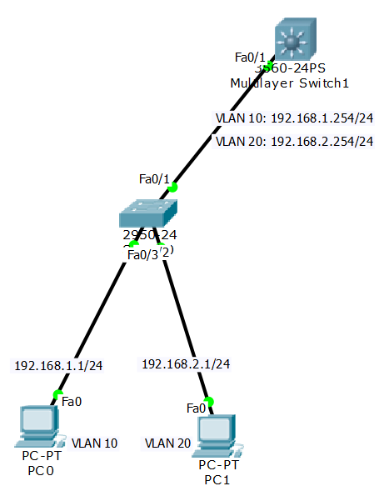

1.2 根据标识进行三层交换机和3560和二层交换机2950的配置，实现VLAN和端口绑定；
三层交换机3560完整配置命令：
vlan 10
name CS
vlan 20
name EE
interface vlan 10
ip address 192.168.1.254 255.255.255.0
no shutdown
interface vlan 20
ip address 192.168.2.254 255.255.255.0
no shutdown
exit
interface fa0/1
switchport trunk encasulation dot1q
switchport mode trunk
interface fa0/2
switchport trunk encasulation dot1q
switchport mode trunk
exit
exit
show vlan
show run
show running-config

二层交换机2950完整配置命令：
Switch>en
Switch#conf t
Enter configuration commands, one per line. End with CNTL/Z.
Switch(config)#hostname SA
SA(config)#vlan 10
SA(config-vlan)#name CS
SA(config-vlan)#vlan 20
SA(config-vlan)#name EE
SA(config-vlan)#interface fa0/1
SA(config-if)#switchport mode trunk
SA(config-if)#interface fa0/2
SA(config-if)#switchport access vlan 10
SA(config-if)#interface fa0/3
SA(config-if)#switchport mode access
SA(config-if)#switchport access vlan 20
SA(config-if)#exit
SA(config)#exit

1.3 VLAN间可达性测试截图：
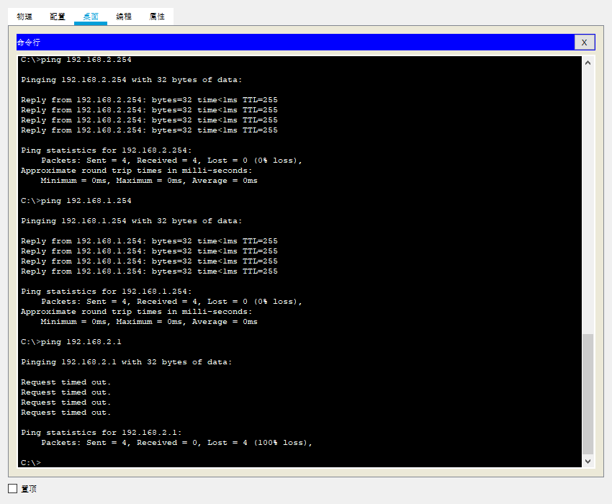

实验步骤2

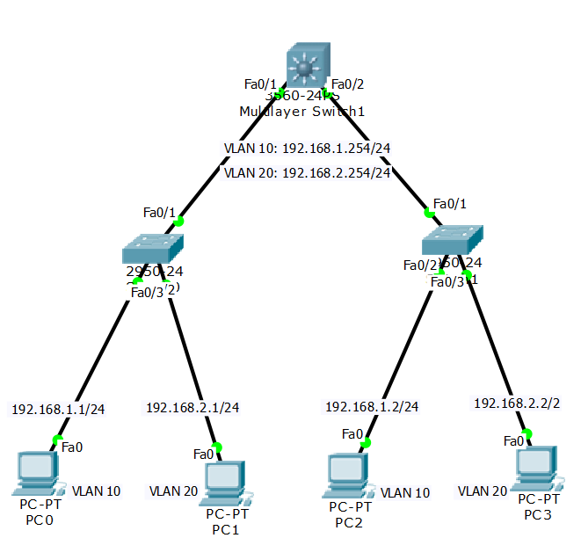
2.1 连接拓扑图并完成右侧交换机SB的配置和主机和配置

二层交换机2950完整配置命令：
Switch>en
Switch#conf t
Enter configuration commands, one per line. End with CNTL/Z.
Switch(config)#hostname SB
SB(config)#vlan 10
SB(config-vlan)#name CS
SB(config-vlan)#vlan 20
SB(config-vlan)#name EE
SB(config-vlan)#exit
SB(config)#interface fa0/1
SB(config-if)#switchport mode trunk
SB(config-if)#interface fa0/2
SB(config-if)#switchport mode access
SB(config-if)#switchport access vlan 10
SB(config-if)#interface fa0/3
SB(config-if)#switchport mode access
SB(config-if)#switchport access vlan 20
SB(config-if)#exit
SB(config)#exit

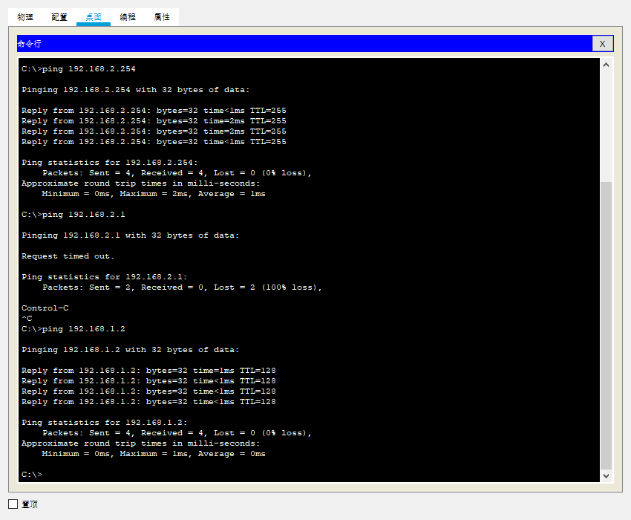

实验步骤3
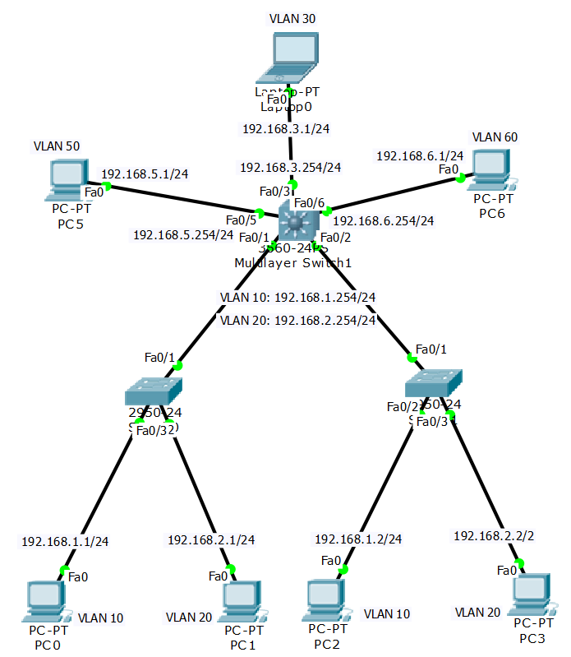

3.1 按拓扑所示，连接各设备，并进行详细标注。将自己的拓扑图截图：
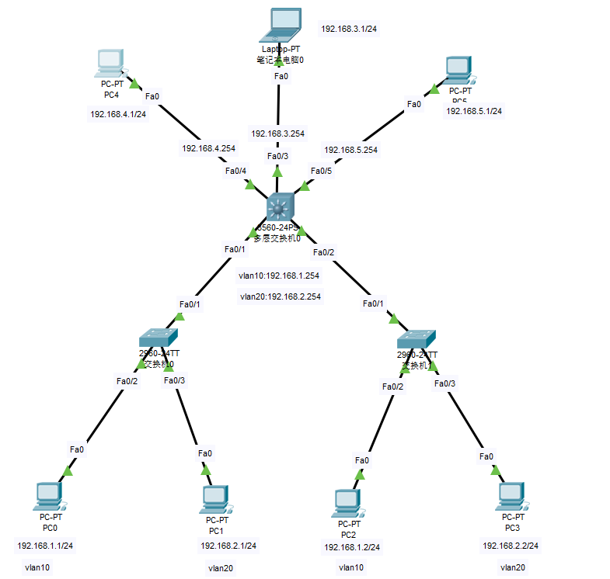
3.2 配置各交换机，实现全网可连通，提供以下主机间用Ping命令测试连通性的截图：

PC0-PC6
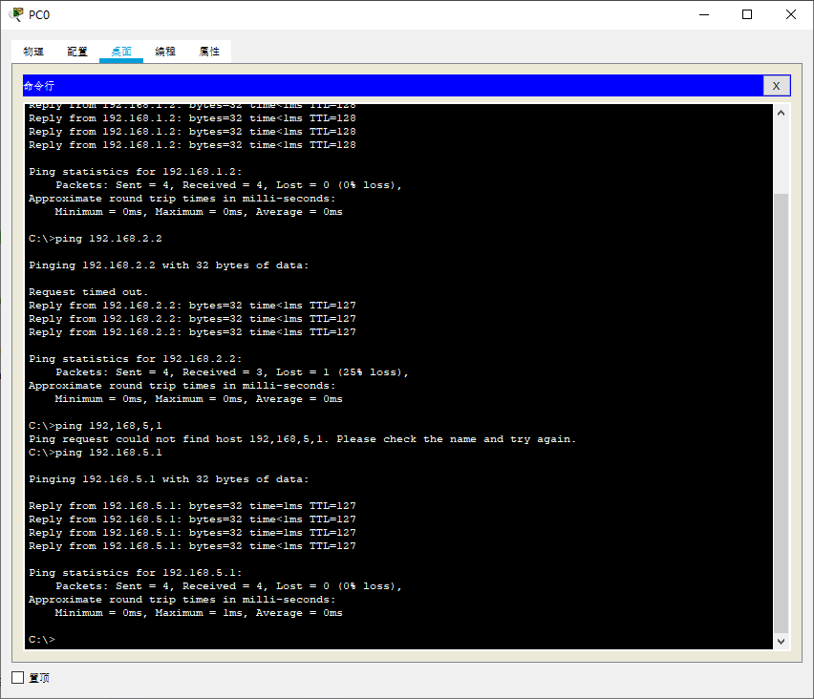
PC3-Laptop0
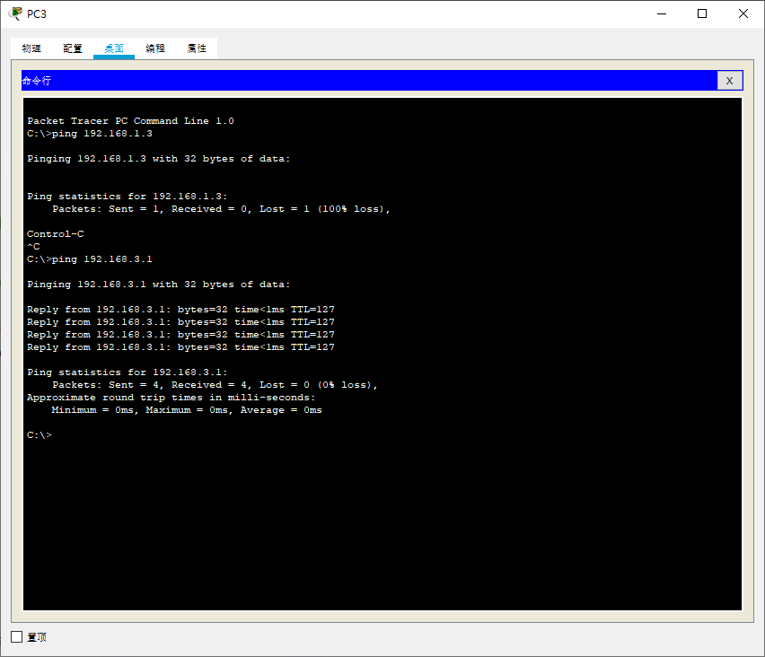

PC1-PC2
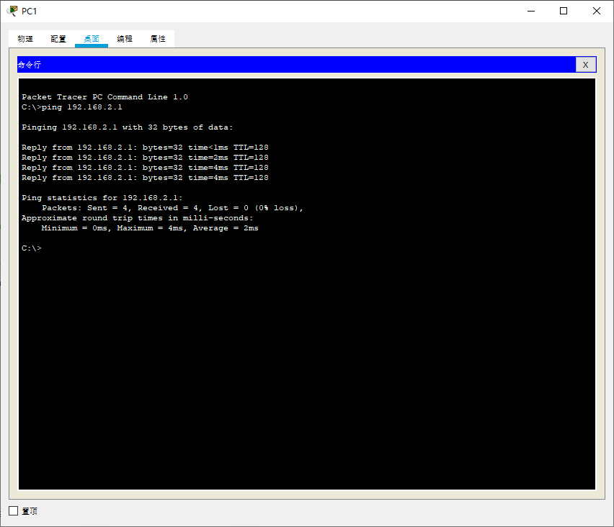
3.3 在三层交换机3560上运行show running-config命令，将结果复制到以下单元格中：
XBH#show running-config
Building configuration...

Current configuration : 1680 bytes
!
version 12.2(37)SE1
no service timestamps log datetime msec
no service timestamps debug datetime msec
no service password-encryption
!
hostname XBH
!
!
!
!
!
!
ip routing
!
!
!
!
!
!
!
!
!
!
!
!
!
!
spanning-tree mode pvst
!
!
!
!
!
!
interface FastEthernet0/1
switchport trunk encapsulation dot1q
switchport mode trunk
!
interface FastEthernet0/2
switchport trunk encapsulation dot1q
switchport mode trunk
!
interface FastEthernet0/3
no switchport
ip address 192.168.3.254 255.255.255.0
duplex auto
speed auto
!
interface FastEthernet0/4
no switchport
ip address 192.168.4.254 255.255.255.0
duplex auto
speed auto
!
interface FastEthernet0/5
no switchport
ip address 192.168.5.254 255.255.255.0
duplex auto
speed auto
!
interface FastEthernet0/6
!
interface FastEthernet0/7
!
interface FastEthernet0/8
!
interface FastEthernet0/9
!
interface FastEthernet0/10
!
interface FastEthernet0/11
!
interface FastEthernet0/12
!
interface FastEthernet0/13
!
interface FastEthernet0/14
!
interface FastEthernet0/15
!
interface FastEthernet0/16
!
interface FastEthernet0/17
!
interface FastEthernet0/18
!
interface FastEthernet0/19
!
interface FastEthernet0/20
!
interface FastEthernet0/21
!
interface FastEthernet0/22
!
interface FastEthernet0/23
!
interface FastEthernet0/24
!
interface GigabitEthernet0/1
!
interface GigabitEthernet0/2
!
interface Vlan1
no ip address
shutdown
!
interface Vlan10
mac-address 0090.0c4c.2801
ip address 192.168.1.254 255.255.255.0
!
interface Vlan20
mac-address 0090.0c4c.2802
ip address 192.168.2.254 255.255.255.0
!
ip classless
!
ip flow-export version 9
!
!
!
!
!
!
!
!
line con 0
!
line aux 0
!
line vty 0 4
login
!
!
!
!
end

3.4 在二层交换机SA上运行show running-config命令，将结果复制到以下单元格中：
SA#show running-config
Building configuration...

Current configuration : 1199 bytes
!
version 12.2
no service timestamps log datetime msec
no service timestamps debug datetime msec
no service password-encryption
!
hostname SA
!
!
!
!
!
spanning-tree mode pvst
spanning-tree extend system-id
!
interface FastEthernet0/1
switchport mode trunk
!
interface FastEthernet0/2
switchport access vlan 10
switchport mode access
!
interface FastEthernet0/3
switchport access vlan 20
switchport mode access
!
interface FastEthernet0/4
!
interface FastEthernet0/5
!
interface FastEthernet0/6
!
interface FastEthernet0/7
!
interface FastEthernet0/8
!
interface FastEthernet0/9
!
interface FastEthernet0/10
!
interface FastEthernet0/11
!
interface FastEthernet0/12
!
interface FastEthernet0/13
!
interface FastEthernet0/14
!
interface FastEthernet0/15
!
interface FastEthernet0/16
!
interface FastEthernet0/17
!
interface FastEthernet0/18
!
interface FastEthernet0/19
!
interface FastEthernet0/20
!
interface FastEthernet0/21
!
interface FastEthernet0/22
!
interface FastEthernet0/23
!
interface FastEthernet0/24
!
interface GigabitEthernet0/1
!
interface GigabitEthernet0/2
!
interface Vlan1
no ip address
shutdown
!
!
!
!
line con 0
!
line vty 0 4
login
line vty 5 15
login
!
!
!
!
end

3.5 在二层交换机SB上运行show running-config命令，将结果复制到以下单元格中：
SB#show running-config
Building configuration...

Current configuration : 1199 bytes
!
version 12.2
no service timestamps log datetime msec
no service timestamps debug datetime msec
no service password-encryption
!
hostname SB
!
!
!
!
!
spanning-tree mode pvst
spanning-tree extend system-id
!
interface FastEthernet0/1
switchport mode trunk
!
interface FastEthernet0/2
switchport access vlan 10
switchport mode access
!
interface FastEthernet0/3
switchport access vlan 20
switchport mode access
!
interface FastEthernet0/4
!
interface FastEthernet0/5
!
interface FastEthernet0/6
!
interface FastEthernet0/7
!
interface FastEthernet0/8
!
interface FastEthernet0/9
!
interface FastEthernet0/10
!
interface FastEthernet0/11
!
interface FastEthernet0/12
!
interface FastEthernet0/13
!
interface FastEthernet0/14
!
interface FastEthernet0/15
!
interface FastEthernet0/16
!
interface FastEthernet0/17
!
interface FastEthernet0/18
!
interface FastEthernet0/19
!
interface FastEthernet0/20
!
interface FastEthernet0/21
!
interface FastEthernet0/22
!
interface FastEthernet0/23
!
interface FastEthernet0/24
!
interface GigabitEthernet0/1
!
interface GigabitEthernet0/2
!
interface Vlan1
no ip address
shutdown
!
!
!
!
line con 0
!
line vty 0 4
login
line vty 5 15
login
!
!
!
!
end

实验步骤4
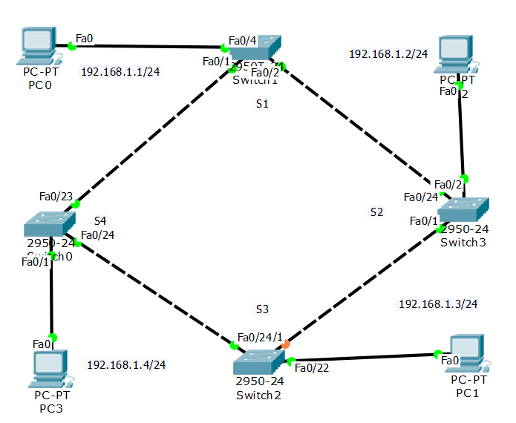
4.1 按该结构绘制拓扑图，截图如下：
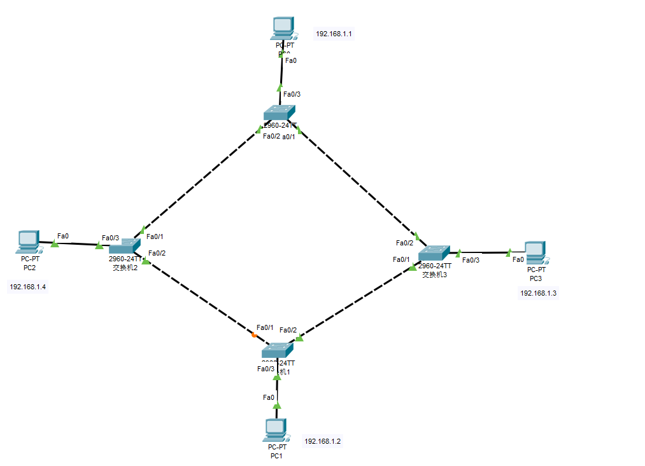

4.2 写出简单PDU从PC0-PC1的路径
PC0->交换机0->交换机3->交换机1->PC1

4.3 关闭Switch2的F0/24, 写出简单PDU从PC0-PC1的路径
PC0->交换机0->交换机2->交换机1->PC1

4.4 关闭所有交换机的STP协议，再打开Switch2的F0/24，添加一个广播包，查看当前的PDU转发情况，并截图：
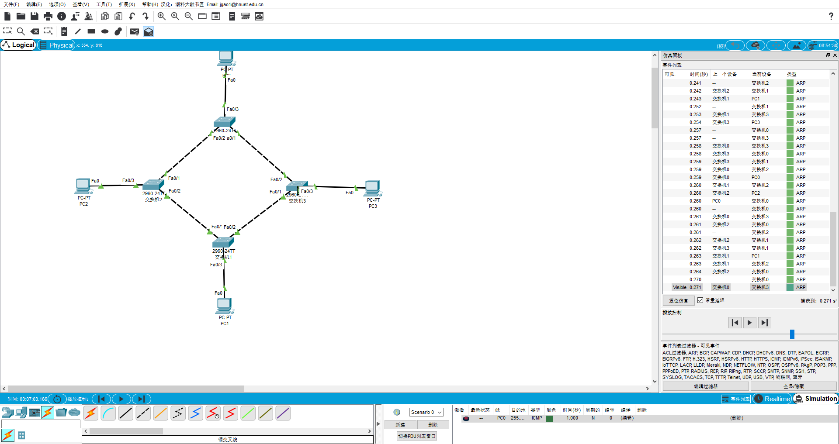

- 收获感想：记录实验感受、操作过程中遇到的困难及解决办法、遗留的问题、意见和建议等。
学习了STP协议的内容，以及多层交换机的配置

